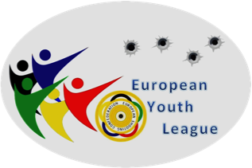


ESC YOUTH LEAGUE
FINAL

BOLOGNA - ITALY

14 th – 16th October 2016
ENTRY FORM

Nation: …………………………

Email: …………………………

Team Leader: …………………………

Coach: …………………………
PARTICIPANTS
Name Surname | Gender | Birth date | Rifle | Pistol
Please return not later than 12th of September 2016 to:
Organizing Committee : Ms.Tania Spicola ; phone. +39- 0039 06/87975504
e-mail: settore.internazionale@uits.it
Ghislaine Briez, email: gbriez@fftir.org

HOTEL RESERVATION

Check in........................... Check out .............................

 | Name Surname | Single Room | Double Room | Triple Room

Please return not later than 12th of September 2016 to:
Organizing Committee : Ms.Tania Spicola ; phone. +39- 0039 06/87975504
e-mail: settore.internazionale@uits.it
Ghislaine Briez, email: gbriez@fftir.org

LUNCH
Please note the number of lunches you would like to order (€ 15.00 per person/per day)
Lunch
Friday | Saturday | Sunday

Please return not later than 12th of September 2016 to:

MEANS OF TRANSPORT

Car Train Flight

Flight information

Arrival |  |  | Departure
Date | Time | Flight n° | Date | Time | Flight n°
From | Person(s) |  | From | Person(s)

Transportation from airport/range/airport , Yes No

Cost €40,00 per person

Please return not later than 12th of September 2016 to:
Organizing Committee : Ms.Tania Spicola ; phone. +39- 0039 06/87975504
e-mail: settore.internazionale@uits.it
Ghislaine Briez, email: gbriez@fftir.org

